Lab 1a Report by Jonathan Bronfman

1. Docker Verification and Dashboard
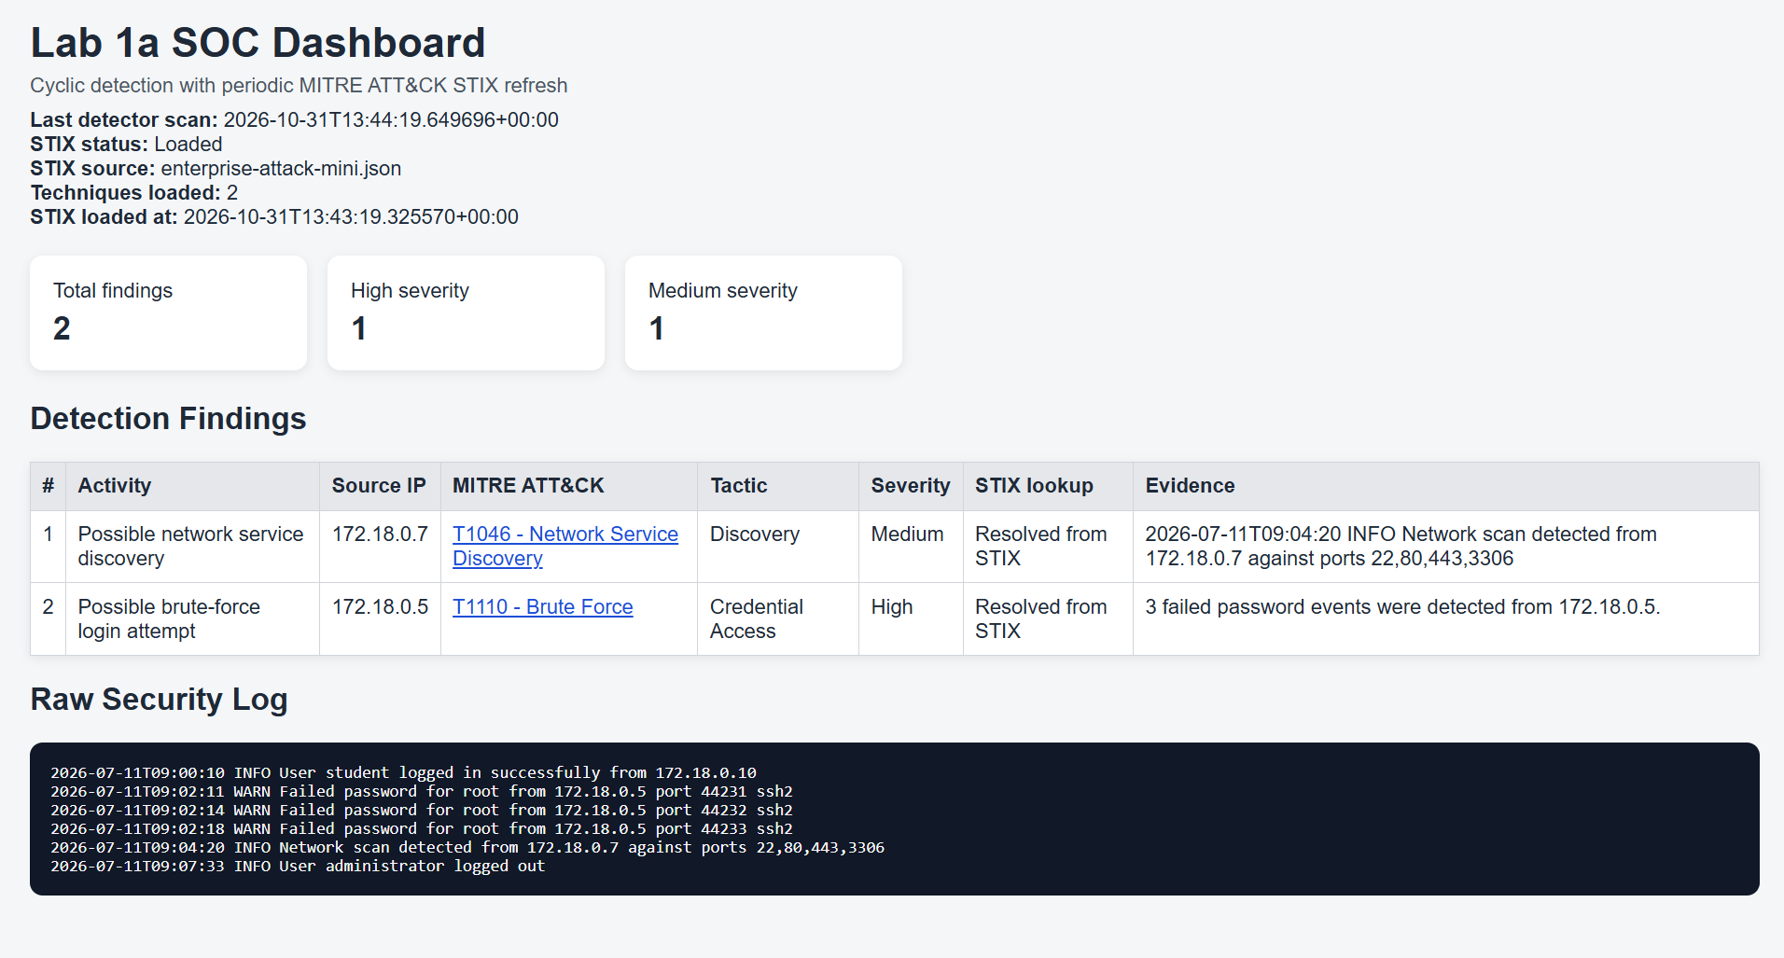

2. Initial Findings from clean baseline
Total Findings:
1 High-severity finding: MITRE Technique T1110 (Brute Force) from source IP 172.18.0.5
1 Medium-severity finding: MITRE Technique T1046 (Network Service Discovery) from source IP 172.18.0.7.

3. Mapping Table
Evidence | Rule Trigger | Technique | Tactic | Uncertainty
Three “Failed password for root from 172.18.0.5” log records | At least 3 failed password events from the same source IP. | T1110 (Brute Force) | Credential Access | Does not record successful authentication, could be a legit user mistyping
INFO Network scan detected from 172.18.0.7 against ports 22,80,443,3306 | The log contains 'network scan detected'. | T1046 (Network Service Discovery) | Discovery | Only matches log text, Does not analyze actual traffic

4. Controlled Experiments

C1
Action: Deleted one failed password entry for 172.18.0.5, leaving 2 failed password entries.
Predicted Result: T1110 disappears, T1046 remains. Total findings = 1.
Actual Result: 1 finding (T1046 only).
Explanation: The count for 172.18.0.5 dropped below threshold (3), so the rule was not triggered.

C2
Action: Restored 3 failed password entries but assigned a unique source IP to each (172.18.0.5, 172.18.0.6, 172.18.0.8).
Predicted Result: No T1110 finding generated; Total findings = 1
Actual Result: 1 finding (T1046 only).
Explanation: The detector aggregates failures strictly by unique source IP. Each individual IP accumulated only 1 failure, staying below the threshold of 3.

C3
Action: Appended 3 synthetic failed password entries from source IP 192.0.2.55
Predicted Result: A new T1110 finding appears for 192.0.2.55
Actual Result: T1046 for 172.18.0.7, T1110 for 192.0.2.55
Explanation: 192.0.2.55 logged 3 failed authentication attempts, crossing threshold and triggering a new candidate finding.

C4
Action: Appended “2026-10-22T10:02:00Z INFO Network scan detected from 192.0.2.77 against ports 22,80,443”
Predicted Result: A second T1046 finding appears for 192.0.2.77
Actual Result: 3 findings, T1046 for 172.18.0.7, T1110 for 192.0.2.55, T1046 for 192.0.2.77
Explanation: The detector matched the explicit substring "network scan detected" in the appended line and created a separate T1046 finding for source IP 192.0.2.77.

5. Simulator Activity Observation

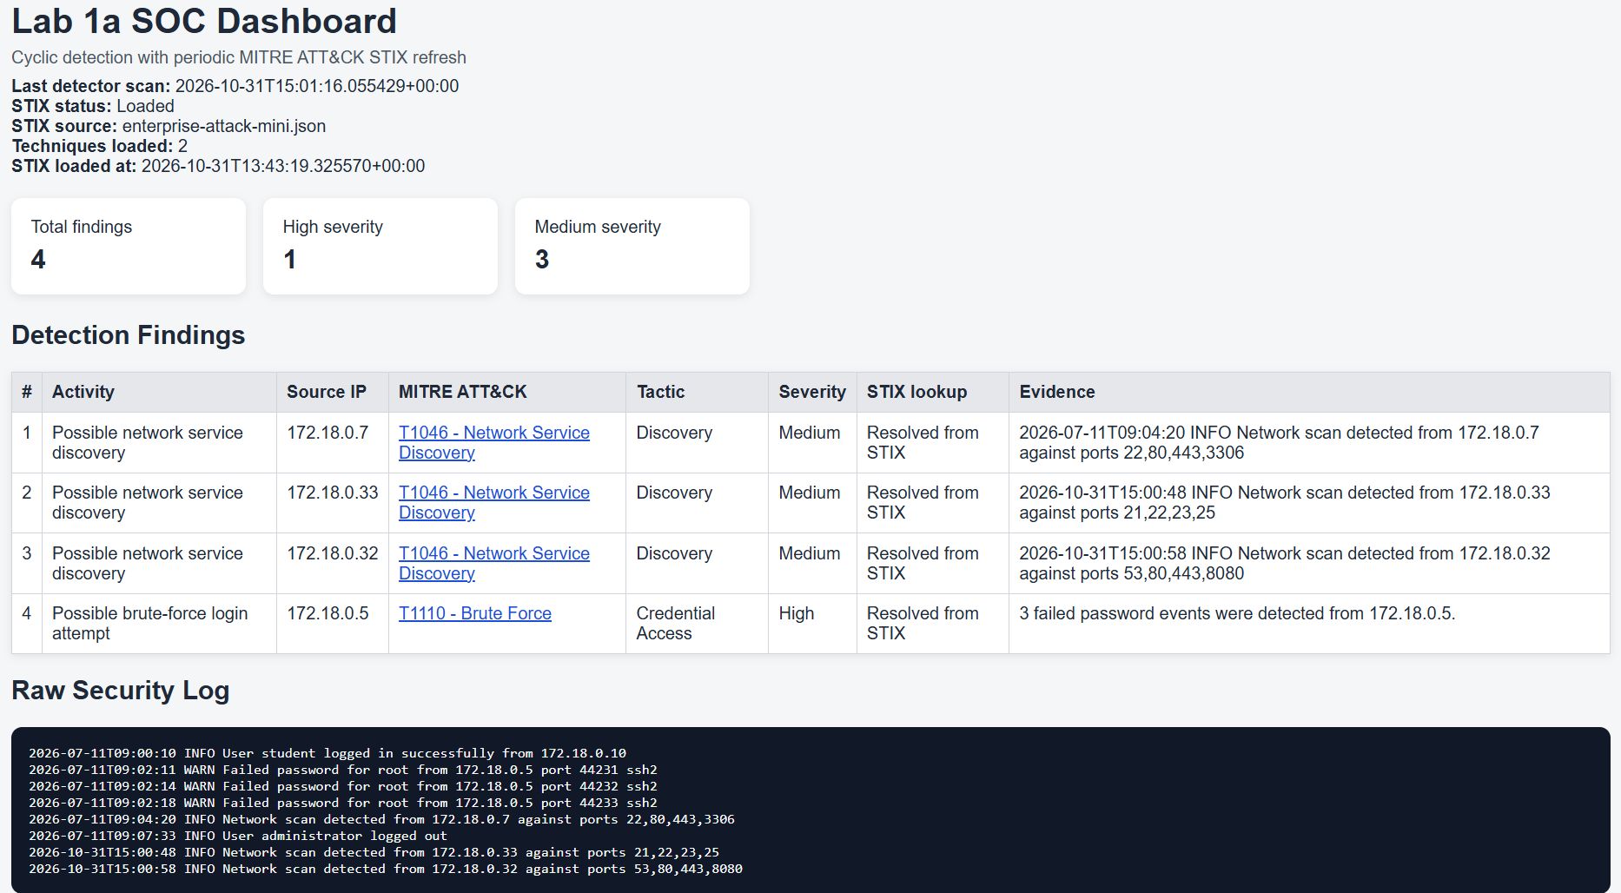
We can observe two new findings about possible network service discoveries:
First, 172.18.0.33 against ports 21,22,23,25.
Second, 172.18.0.32 against ports 53,80,443,8080.
Seeing as there were network scans from both, new findings were added, classified as T1046 Network Service Discovery, and were assigned medium severity.

6. SOC Narrative
On July 11, 2026, raw system logs recorded three sequential authentication failures for the root account originating from source IP 172.18.0.5 between 09:02:11 and 09:02:18. At 09:04:20, an explicit log entry flagged a network port scan targeting ports 22, 80, 443, and 3306 from source IP 172.18.0.7. Rule-based detection correlated these records with MITRE ATT&CK techniques T1110 (Brute Force) and T1046 (Network Service Discovery), triggering High and Medium dashboard alerts, respectively.
Analytical Interpretation: While these rule matches align with standard reconnaissance and credential-access techniques, raw log observations alone do not establish malicious intent or successful system compromise. The failed logins from 172.18.0.5 lack follow-up evidence of successful access, and the scan from 172.18.0.7 may reflect routine internal vulnerability management. Further SOC investigation and network telemetry are required prior to taking escalation or blocking actions.

